

This site explains in basic terms the principals that are used to create the refrigeration effect. It should probably not be considered as a serious introduction into the world of thermodynamics but is rather meant to enlighten any curious and unknowing observer as to how this magical effect occurs. Graphics and animations are used in an attempt to make it very easy to understand the concepts involved. This site is to satisfy curiosity, and perhaps instill interest, but is admittedly not the standard textbook way of introducing someone to such a complex topic. Instead a somewhat light-hearted approach is taken and the process is described in a manner that anyone can understand. So, welcome to my site and have fun.
First of all, did you know that there is no such thing as cold? You can describe something as cold and everyone will know what you mean, but cold really only means that something contains less heat than something else. All there really is, is greator and lesser amounts of heat. The definition of refrigeration is The Removal and Relocation of Heat.
So if something is to be refrigerated, it is to have heat removed from it. If you have a warm can of pop at say 80 degrees Fahrenheit and you would prefer to drink it at 40 degrees, you could place it in your fridge for a while, heat would somehow be removed from it, and you could eventually enjoy a less warm pop.(oh, alright, a cold pop.) But lets say you placed that 40 degree pop in the freezer for a while and when you removed it, it was at 35 degrees. See what I mean, even "cold" objects have heat content that can be reduced to a state of "less heat content". The limit to this process would be to remove all heat from an object. This would occur if an object was cooled to Absolute zero which is -273 C or -460 F. They come pretty close to this under laboratory conditions and strange things like electrical superconductivity occur.

How do things get colder
There are 3 main ways;
- Radiation
- Conduction
- Convection
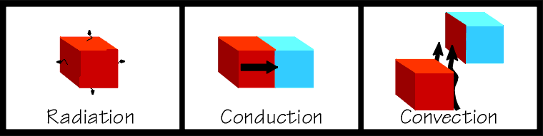
The latter two are used extensively in the design of refrigeration equipment. If you place two objects together so that they remain touching, and one is hot and one is cold, heat will flow from the hot object into the cold object. This is called conduction. This is an easy concept to grasp and is rather like gravitational potential, where a ball will try to roll down an inclined plane. If you were to fan a hot plate of food it would cool somewhat. Some of the heat from the food would be carried away by the air molecules. That is called convection. And if you kicked a glowing hot ember away from a bonfire, and you watched it glowing dimmer and dimmer, it is cooling itself by radiating heat away. Note that an object dosen't have to be glowing in order to radiate heat, all things use combinations of these methods to come to equilibrium with their surroundings. So you can see that in order to refrigerate something, we must find a way to expose our object to something that is colder than itself and nature will take over from there. We are getting closer to talking about the actual mechanics of a refrigerating system, but there are some other important concepts to discuss first.

The States of Matter
They are of course; solid, liquid and gas. It is important to note that heat must be added to a substance to make it change state from solid to liquid and to a gas. It is just as important to note that heat must be removed from a substance to make it change state from a gas to a liquid and to a solid.

The Magic of Latent Heat
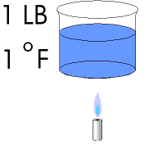
Long ago it was found that we needed a way to quantify heat. Something more precise than "less heat" or "more heat" or "a great deal of heat" was required. This was a fairly easy task to accomplish. They took 1 LB of water and heated it 1 degree Fahrenheit. The amount of heat that was required to do this was called 1 BTU (British Thermal Unit). The refrigeration industry has long since utilized this definition. You can for example purchase a 6000 BTUH window air conditioner. This would be a unit that is capable of relocating 6000 BTU's of heat per hour. A larger unit capable of 12,000 BTUH could also be called a one Ton unit. There are 12.000 BTU's in 1 Ton.
To raise the temperature of 1 LB of water from 40 degrees to 41 degrees would take 1 BTU. To raise the temperature of 1 LB of water from 177 degrees to 178 degrees would also take 1 BTU. However, if you tried raising the temperature of water from 212 degrees to 213 degrees you would not be able to do it. Water boils at 212 degrees and would prefer to change into a gas rather than let you get it any hotter. Something of utmost importance occurs at the boiling point of a substance. If you did a little experiment and added 1 BTU of heat at a time to 1 LB of water, you would notice that the water temperature would increase by 1 degree each time. That is until you reached 212 degrees. Then something changes. You would keep adding BTU's, but the water would not get any hotter! It would change state into a gas and it would take 970 BTU's to vaporize that pound of water. This is called the Latent heat of Evaporization and in the case of water it is 970 BTU's per pound.
So what! you say. When are you going to tell me how the refrigeration effect works? Well hang in there, you have just learned about 3/4 of what you need to know to understand the process. What keeps that beaker of water from boiling when it is at room temperature? If you say it's because it is not hot enough, sorry but you are wrong. The only thing that keeps it from boiling is the pressure of the air molecules pressing down on the surface of the water. When you heat that water to 212 degrees and then continue to add heat, what you are doing is supplying sufficient energy to the water molecules to overcome the pressure of the air and allow them to escape from the liquid state. If you took that beaker of water to outer space where there is no air pressure the water would flash into a vapour. If you took that beaker of water to the top of Mt.Everest where there is much less air pressure, you would find that much less heat would be needed to boil the water. (it would boil at a lower temperature than 212 degrees). So water boils at 212 degrees at normal atmospheric pressure. Lower the pressure and you lower the boiling point. Therefore we should be able to place that beaker of water under a bell jar and have a vaccuum pump extract the air from within the bell jar and watch the water come to a boil even at room temperature. This is indeed the case!
A liquid requires heat to be added to it in order for it to overcome the air pressure pressing down on its' surface if it is to evaporate into a gas. We just learned that if the pressure above the liquids surface is reduced it will evaporate easier. We could look at it from a slightly different angle and say that when a liquid evaporates it absorbs heat from the surrounding area. So, finding some fluid that evaporates at a handier boiling point than water (IE: lower) was one of the first steps required for the development of mechanical refrigeration.
Chemical Engineers spent years experimenting before they came up with the perfect chemicals for the job. They developed a family of hydroflourocarbon refrigerants which had extremely low boiling points. These chemicals would boil at temperatures below 0 degrees F at atmospheric pressure. So finally, we can begin to describe the mechanical refrigeration process.

Part 2
There are 4 main components in a mechanical refrigeration system:
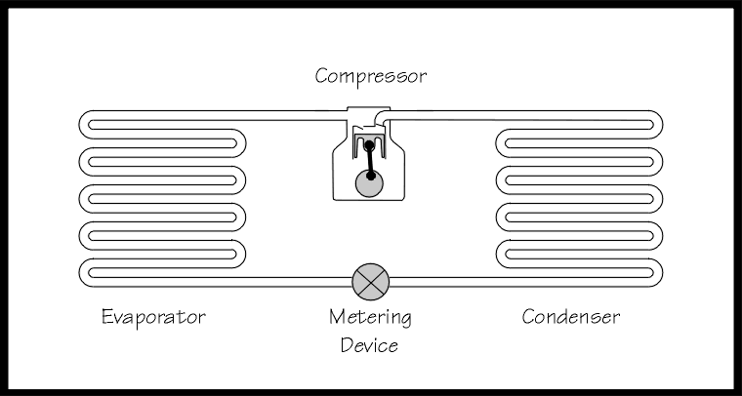
The compressor is a vapor compression pump which uses pistons or some other method to compress the refrigerant gas and send it on it's way to the condenser. The condenser is a heat exchanger which removes heat from the hot compressed gas and allows it to condense into a liquid. The liquid refrigerant is then routed to the metering device. This device restricts the flow by forcing the refrigerant to go through a small hole which causes a pressure drop. And what did we say happens to a liquid when the pressure drops? If you said it lowers the boiling point and makes it easier to evaporate, then you are correct. And what happens when a liquid evaporates? Didn't we agree that the liquid will absorb heat from the surrounding area? This is indeed the case and you now know how refrigeration works. This component where the evaporation takes place is called the evaporator. The refrigerant is then routed back to the compressor to complete the cycle. The refrigerant is used over and over again absorbing heat from one area and relocating it to another. Remember the definition of refrigeration? (the removal and relocation of heat)

Heat Transfer Rates
One thing that we would like to optimize in the refrigeration loop is the rate of heat transfer. Materials like copper and aluminum are used because they have very good thermal conductivity. In other words heat can travel through them easily. Increasing surface area is another way to improve heat transfer. Have you noticed that small engines have cooling fins formed into the casting around the piston area? This is an example of increasing the surface area in order to increase the heat transfer rate. The hot engine can more easily reject the unwanted heat through the large surface area of the fins exposed to the passing air. Refrigeration heat transfer devices like air cooled condensers and evaporators are often made out of copper pipes with aluminum fins and further enhanced with fans to force air through the fins.

Metering Device
We will now take a closer look at the individual components of the system. We will start with the metering device. There are several types but all perform the same general function which is to cause a pressure drop. There should be a full column of liquid refrigerant supplying the inlet of the metering device. When it is forced to go through a small oriface it loses a lot of the pressure it had on the upstream side of the device. The liquid refrigerant is sort of misted into the evaporator. So not only is the pressure reduced, the surface area of the liquid is vastly increased. It is hard to try and light a log with a match but chop the log into toothpick sized slivers and the pile will go up in smoke. The surface area of zillions of liquid droplets is much greater than the surface area of the column of liquid in the pipe feeding the metering device. The device has this name because it meters the flow of refrigerant into the evaporator. The next graphic shows a capillary line metering device. This is a long small tube which has an inside diameter much smaller than a pencil lead. You can imagine the large pressure drop when the liquid from a 1/4 " pipe is forced to go through such a small opening. The capillary line has no moving parts and can not respond to changing conditions like a changing thermal load on the evaporator. I have also added a few labels showing the names of some of the pipes.
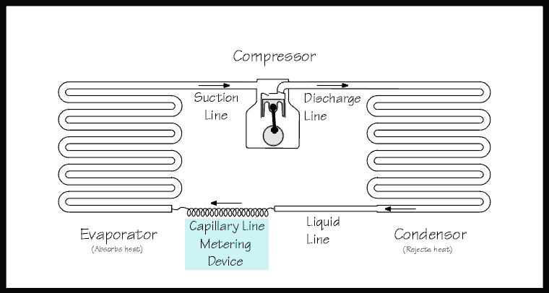

The Evaporator
The metering device has sprayed low pressure droplets of refrigerant into the evaporator. The evaporator could be the forced air type and could be constructed of many copper tubes which conduct heat well. To further enhance heat transfer the pipes could have aluminum fins pressed onto them. This vastly increases the surface area that is exposed to the air. And this type of evaporator could have a fan motor sucking air through the fins. The evaporator would be capable of reducing the temperature of air passing through the fins and this is a prime example of the refrigeration effect. If that evaporator was located in a walk in cooler, the air would be blown out into the box and would pick up heat from the product; let's say it is a room full of eggs. The flow of heat would be egg core/egg shell/circulating air/aluminum fins/copper evaporator pipe/liquid droplet of refrigerant. The droplet of refrigerant has the capability of absorbing a large quantity of heat because it is under conditions where it is just about ready to change state into a gas. We have lowered it's pressure, we have increased surface areas and now we are adding heat to it. Just like water, refrigerants also have ratings for Latent Heats of Evaporization in BTU's per LB. When heat is picked up from the air stream, the air is by definition cooled and is blown back out into the box to take another pass over the eggs and pick up more heat. This process continues until the eggs are cooled to the desired temperature and then the refrigeration system shuts off and rests. But what about our droplet of refrigerant. By now it might have picked up so much heat that it just couldn't stand it anymore and it has evaporated into a gas. It has served it's purpose and is subjected to a suction coming from the outlet pipe of the evaporator. This pipe is conveniently called the suction line. Our little quantity of gas joins lots of other former droplets and they all continue on their merry way to their next destination.

The Compressor
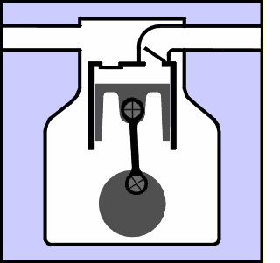
The compressor performs 2 functions. It compresses the gas (which now contains the heat from the eggs) and it moves the refrigerant around the loop so it can perform it's function over and over again. We want to compress it because that is the first step in forcing the gas to go back into a liquid form. This compression process unfortunatly adds some more heat to the gas but at least this process is also conveniently named; The Heat of Compression. The graphic shows a reciprocating compressor. It has piston(s) that go up and down. On the downstroke refrigerant vapour is drawn into the cylinder. On the upstroke those vapors are compressed. There are thin valves that act like check valves and keep the vapours from going back where they came from. They open and close in response to the refrigerant pressures being exerted on them by the action of the piston. The hot compressed gas is discharged out the...you guessed it; Discharge Line. It continues towards the last main component.

The Condenser
The condenser is similar in appearance to the evaporator. It utilizes the same features to effect heat transfer. The condenser is similar in appearance to the evaporator. It utilizes the same features to effect heat transfer as the evaporator does. However, this time the purpose is to reject heat so that the refrigerant gas can condense back into a liquid in preparation for a return trip to the evaporator. If the hot compressed gas was at 135 degrees and the air being sucked through the condenser fins was at 90 degrees, heat will flow downhill like a ball wants to roll down an inclined plane and be rejected into the air stream. Heat will have been removed from one place and relocated to another as the definition of refrigeration describes. As long as the compressor is running it will impose a force on the refrigerant to continue circulating around the loop and continue removing heat from one location and rejecting it into another area.

Superheat and Slugging
There is another very common type of metering device called a TX Valve. It's full name is Thermostatic Expansion Valve, and you will be thankful to know that its' short form is TXV. This valve has the additional capability of modulating the refrigerant flow. This is a nice feature because if the load on the evaporator changes the valve can respond to the change and increase or decrease the flow accordingly. The next graphic shows this type of metering device and you will note that another component has been added along with it.
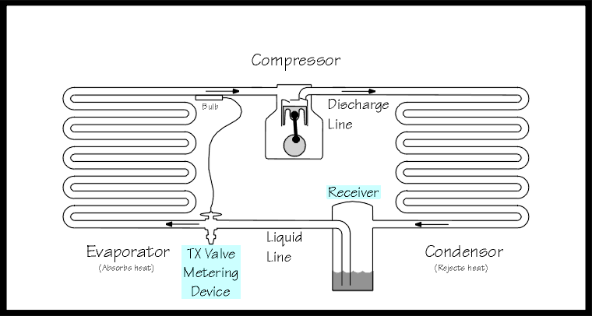
The TXV has a sensing bulb attached to the outlet of the evaporator. This bulb senses the suction line temperature and sends a signal to the TXV allowing it to adjust the flow rate. This is important because if not all the refrigerant in the evaporator changes state into a gas, there could be liquid refrigerant content returning to the compressor. This can be disasterous to the compressor. A liquid can not be compressed and if a compressor tries to compress a liquid something is going to break and it's not going to be the liquid. The compressor can suffer extreme mechanical damage. This is called liquid slugging.
The flow rate through a TXV is set so that not only is all the liquid hopefully changed to a gas, but there is an additional 10 degree safety margin to insure that all the liquid is changed to a gas. This is called Superheat. At a given temperature any liquid and vapour combination will always be at a specific pressure. There are charts of this relationship called PT Charts which stands for Pressure/Temperature Chart. Now if all the liquid droplets in an evaporator have changed state into a gas, and they still have 1/4 of the evaporator to travel through, this gas will pick up more heat from the load being imposed on the evaporator and even though it is at the same pressure, it will become hotter than the PT Chart says it should be. This heat increase over and above the normal PT relationship is called superheat. It can only take place when there is no liquid in the immediate area and this phonomena is used to create an insurance polocy of sorts. Usually TXV's are set to maintain 10 degrees of superheat and by definition that means that the gas returning to the compressor is at least 10 degrees away from the risk of having any liquid content. A compressor is a vapour compression pump and must not attempt to compress liquid.
That extra component that got added in along with the TX Valve is called a receiver. When the TXV reduces the flow there has to be somewhere for the uneeded refrigerant to go and the receiver is it. Note that there is a dip tube in the outlet side to insure that liquid is what is fed into the liquid line. Liquid must be provided to the TXV not a mixture of liquid and gas. The basic premise is to change a liquid to a gas so you don't want to waste any of the evaporator’s capacity by injecting useless vapour into it. The line that comes from the condensor and goes to the receiver is also given a name. It's called the condensate line.

Accessories
Even though there are only 4 basic components to a refrigeration system there are numerous accessories that can be added. I will only mention a couple of them. The next graphic shows a filter and a sight glass. The filter catches unwanted particles such as welding slag and other unwanted debris and keeps it from clogging up important devices such as TX Valves. It has another function as well. It contains a dessicant which absorbs minute quantities of water which hopefully wasn't in the system in the first place.
The sight glass is a viewing window which allows a mechanic to see if a full column of liquid refrigerant is present in the liquid line.
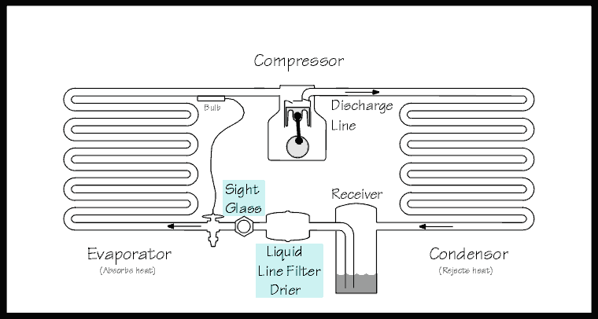
Earlier we discussed heat transfer rates and mentioned surface area as one of the factors. Let's put some fins on our condenser and evaporator. While we are at it lets also add a couple of fan motors to move air through those fins. They are conveniently called the condenser fan motor and evaporator fan motor.
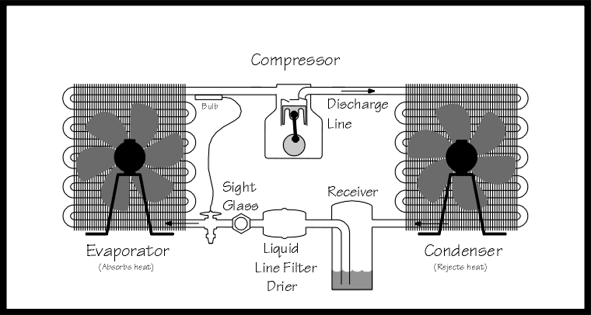

To make our cyber space refrigeration system a little more realistic lets separate the evaporator away from the compressor section and put it inside an insulated box. The leftover components can now be called a Condensing Unit. The insulated box does not conduct heat well. If we lower the temperature of a refrigerated product inside the box we want to slow down the rate of thermal gain from the rest of the world outside the box. There has been oil added to the compressor sump to keep the moving parts inside the compressor lubricated. The suction line returning to the compressor has been sloped to aid in returning oil to the compressor. The oil is slowly depleted from the sump by getting entrained in the refrigerant and proper piping practices must be used to insure its' return. Also notice that the liquid line has been made smaller. The same quantity of refrigerant can be contained in a much smaller pipe when it is in the liquid form. The suction line has been connected to its' proper place on the evaporator; the bottom. Consider the direction of flow, the liquid refrigerant (which probably contains oil stolen from the compressor) enters the top of the evaporator and now has gravity on its' side to return the oil to where it belongs (just like the sloped suction line).
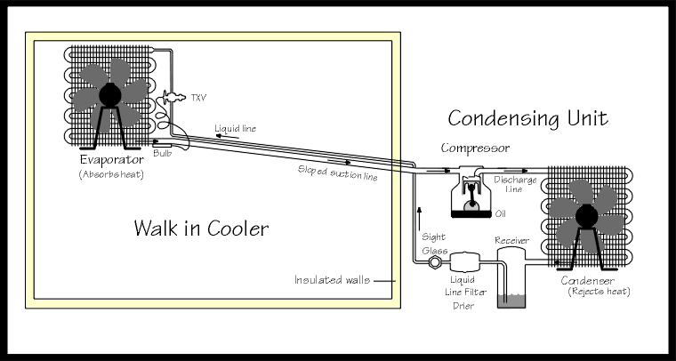
Consider the heat flow within the insulated box. The evaporator is constantly recirculating air in a forced convection loop around the box. As the cold air passes over the product to be refrigerated, once again we see a thermal transfer taking place. If there were a bunch of boxes of warm eggs placed in the cooler some of their heat content would be picked up by the cold air and that air is sucked back into the evaporator. We know what happens then. The heat is transfered through the fins, through the tubing, and into the refrigerant and carried away. That same air has been cooled and is once again discharged back over the product. The next graphic shows this loop and the pink and blue colours represent air with more heat content and less heat content respectively.
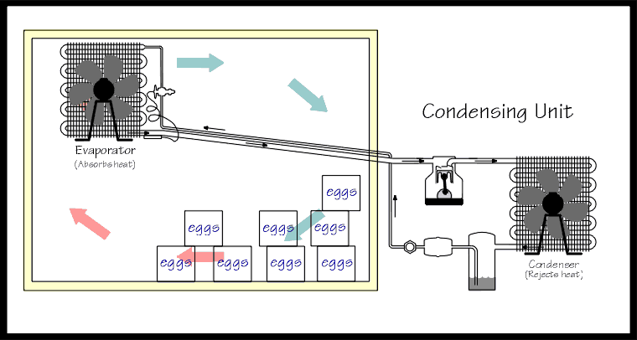
The next graphic is a more pictorial representation of what an actual installation might look like.
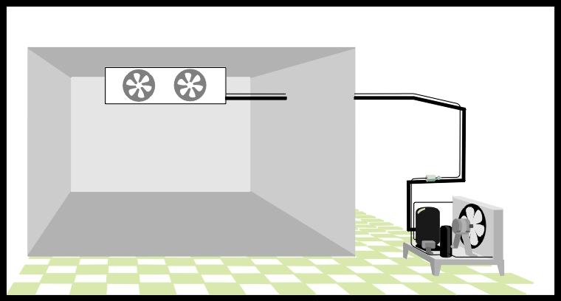
About the Author and this site
This site was created by a refrigeration mechanic with 20+ years of experience. I have had several opportunities over the years to assist apprentices with their training and get a kick out of explaining refrigeration theory in a simplified and empirical manner and watching the reaction when all of a sudden the lights go on and some concept that has remained elusive suddenly starts to make sense. The refrigeration theory classroom is an arena where a course outline must be followed and the student is faced with a huge barrage of material that is supposed to be absorbed. It is not suprising that many students end up with gaps in their understanding of the basic concepts. This site was an attempt to use a common horse sense method of explaining concepts. A serious student will find that I have skipped over vast amounts of introductory material. But that was the initial intention...to allow a lay person an immediate grasp of the refrigeration concept and touch on a few side aspects. I Hope you enjoyed the site.

